User guide of

the user interface :

When you launch the function «GUI_interactive_graph.m», some lines are displayed on matlab :

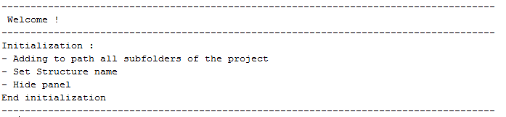

Moreover this window opens :

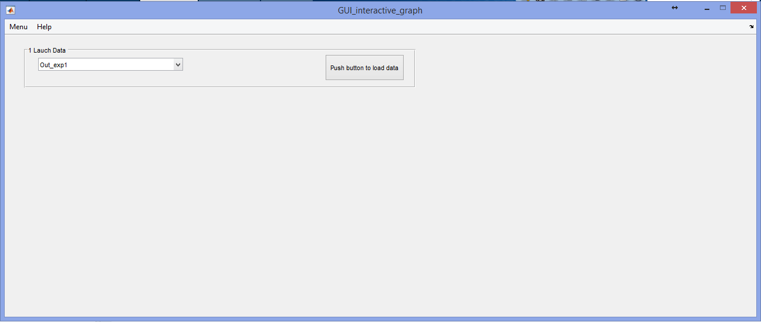

You can select in the pop-up menu which data you want to work on, then click on the button.

These lines are displayed when you click :



And a new part of the user interface appears :

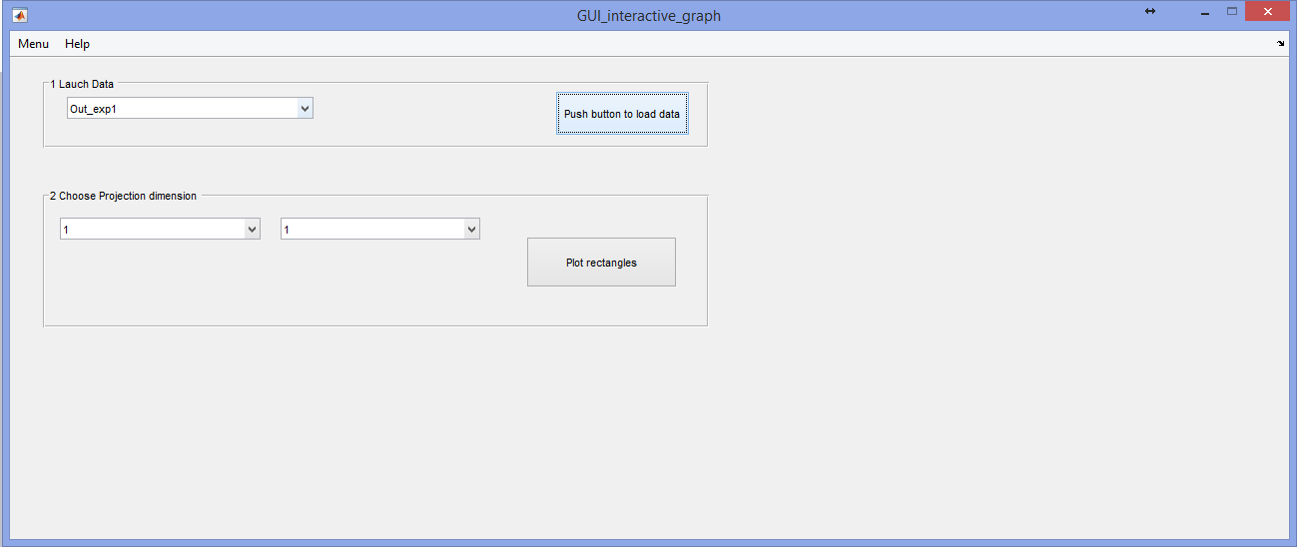

You can now select the two projection dimension you want to see. For instance 1 and 2, then click on the button (plot rectangles) and this graph appears and a new section of the user interface becomes available :

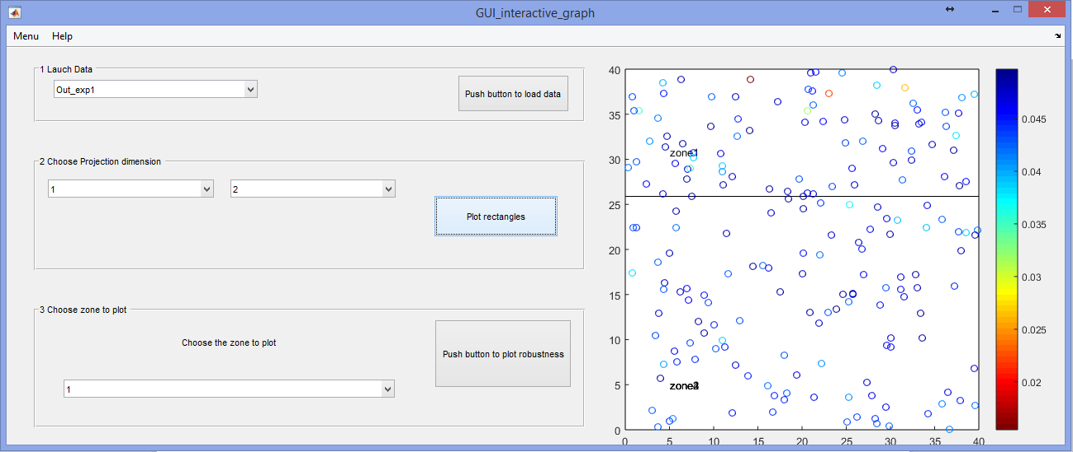

New lines are displayed :



You can see that two rectangles are plot. Each point is colored according to the value of its robustness. The point with the lowess robustness is in zone1 so if you want to plot only zone one you can select ‘1’ in the pop-up menu and click on the button (plot robustness). A new window will opens :

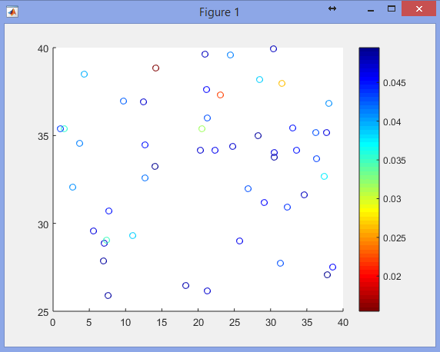

Once again each point is colored according to the value of its robustness. If you want to see its precise value you can click on it and its value and its position will be written next to it. The point with the lowest robustness is the point coloured in dark red. Let’s click on it :

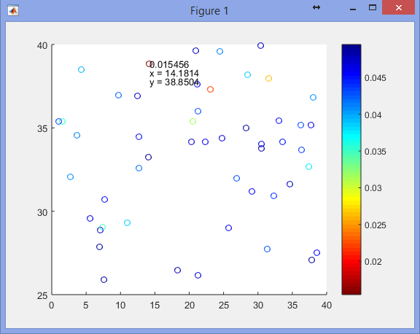

You can click on other points and the values will be added on the graph. If you wish to delete all the text on the figure you can right click with your mouse and all the values will be deleted.

